INTELLIGENT SYSTEM FOR PATTERN RECOGNITION

2021-2022

META LEARNING AND SKILLS COMBINATION FOR ROBOTICS



Project report by Sergio Latrofa - 640584

ABSTRACT

The aim of this project is to analyze recent works concerning themes related to the impact of prior knowledge on the ordinary learning algorithm: meta-learned parameters or particular skills of an intelligent agent can effectively accelerate convergence and simplify training? Different methods to achieve such convenient starting points will be analyzed, ranging from the general purpose MAML (Model agnostic meta learning) and progressively deepening into Reinforcement Learning scenarios (especially Robotics related ones). Analogies and turning points of the various approaches will be highlet, in order to decline an overall view of evolution and specialization of such approaches, as far as some common theoretical background.

1. INTRODUCTION

The general idea that this work explores can be summarized with the existence of some optimal initial parameter configuration for learning tasks, and that some configurations may be learned themselves or even being transferred from other problems or other agent experiences, not necessarily identical to the one on which the model will be subsequently trained. In particular, the idea found several applications into complex Reinforcement Learning problems, like robot control and locomotion, where each training experience of the agent may be very expensive (computationally and even economically) and seldom a non trivial number of them is needed only to learn from scratch a single and very specific task.

The large applicative horizons of this idea are not the only reason behind this review; in fact, the various algorithms, and in particular the loss functions that they optimize (and their regularization terms as well), provide evidence that the approach has both probabilistic and information theoretic foundation, and that several other promising interpretations exist, hopefully being able to bear a number of new algorithms and research works.

This survey will also largely focus on the concept of skill, becoming over and over more present in RL. Skills may be viewed as an abstraction of the classical action, having a thicker granularity and effectively consisting into a sequence of them. Intuitively, such a concept is something very common in the real world, alive agents like quadrupeds, being able to stay up just a few seconds after their birth, as if such ability was known “a priori”.   
Not only the biological plausibility behind the concept of prior skills makes them worth studying, in fact, the most promising and powerful applications would be skill transferring, allowing agents to reuse experience of themselves or others, to offline learn a set of solutions useful to solve several heterogeneous problems (no interaction with the real environment). Therefore the association of skill based RL with the Meta Learning idea is quite easy.

In the next pages, such intuitions will be re-discussed on a more technical level, analyzing algorithms and equations. Some crumbles of the empirical results from the original papers were reported, but the idea is to keep this survey more focused on the theory behind each algorithm, without focusing on experiment details. Final conclusion and possible related ideas will be drawn in the last section.

1. META LEARNING

The process of searching an initial optimal configuration for unknown problems is called “Meta Learning”, and though it has been intuitively considered and theoretically studied from the dawn of learning algorithms, only in recent years several impactful results have been achieved.

2.1 MAML: Model Agnostic Meta Learning

Idea behind this algorithm is to find prior parameters configuration of a gradient-trained model such that it can fastly adapt to a new problem (task) with a small number of updates and examples (few-shot learning).

A task is defined as:  consisting of a loss function , a distribution over initial observations 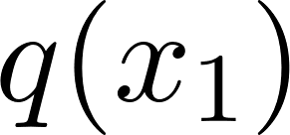, a transition distribution 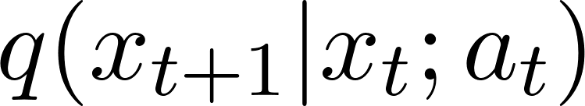, and an episode length . In i.i.d. supervised learning problems, the length is . The model may generate samples of length  by choosing an output at at each time . The loss , provides task-specific feedback, which might be in the form of a misclassification loss or a cost function in a Markov decision process. 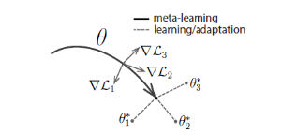

Meta learning for K-shot learning assumes the model to be trained on a distribution over tasks 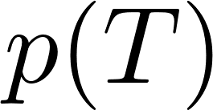, sampling single tasks  and training the model with  related examples.

Model  is then improved according to error on new data from 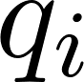 with respect to its parameter. Final meta-performances are tested at the end of meta-training with held out tasks.

Idea behind MAML is that some internal representations are more transferable than others. Is there a way to make such general purpose settings emerge? Intuition is that some parameters can be more sensitive to changes in the task, such that small changes towards  would produce large improvements on any task from 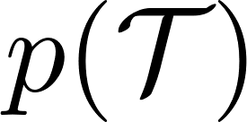, assuming loss to be smooth enough in . Meta objective is expressed as:

/

where to minimize error w.r.t. , the already updated version is considered, according to classical SGD with step-size . So meta learning rule will update the “initial” theta, according to the gradient of its updated version :

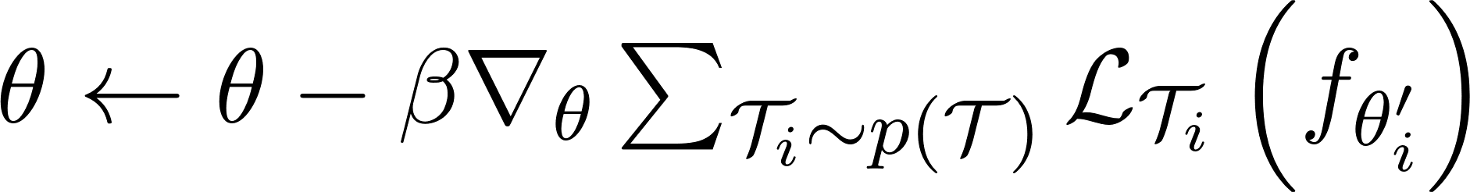

with meta step size . To compute such differentiation (gradient through a gradient), the Hessian is required, involving an additional backward pass through .

To save computation authors propose a first order model approximation, experimentally applied without any performance decay.

The algorithm is easily applicable to supervised tasks like regression and classification (better with some automatic differentiation library). In order to perform MAML in a RL scenarios, (changing MDPs with horizon H), the policy  becomes the model to optimize. Considering a single task  and model 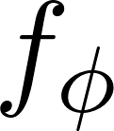, loss is the expected negative reward :



Hence a policy gradient method will be used to estimate gradients of task specific loss as well as of meta-loss; such a solution involves sampling from the current policy and from environments of the task.

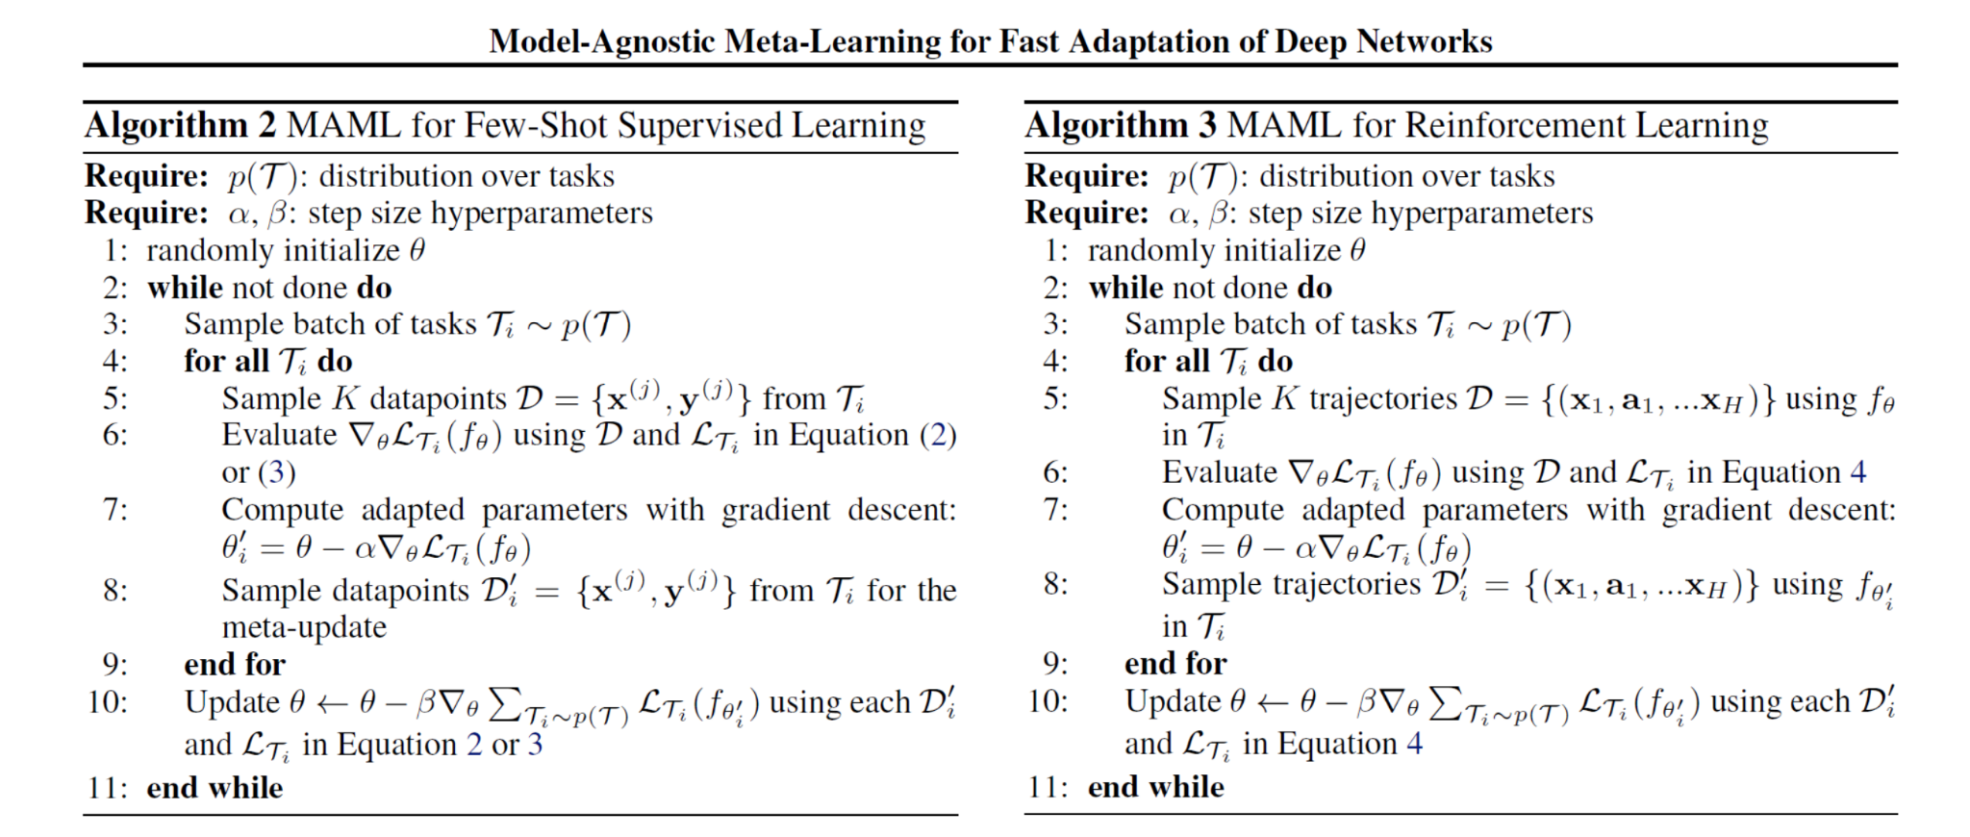

During the empirical evaluation MAML demonstrated to significantly improve performance of meta trained models, both for regression, classification and RL, outperforming random initialization and pre-training. Especially for RL, one important advantage of Meta Learning is the low number of gradient steps sufficient to adapt to the task.

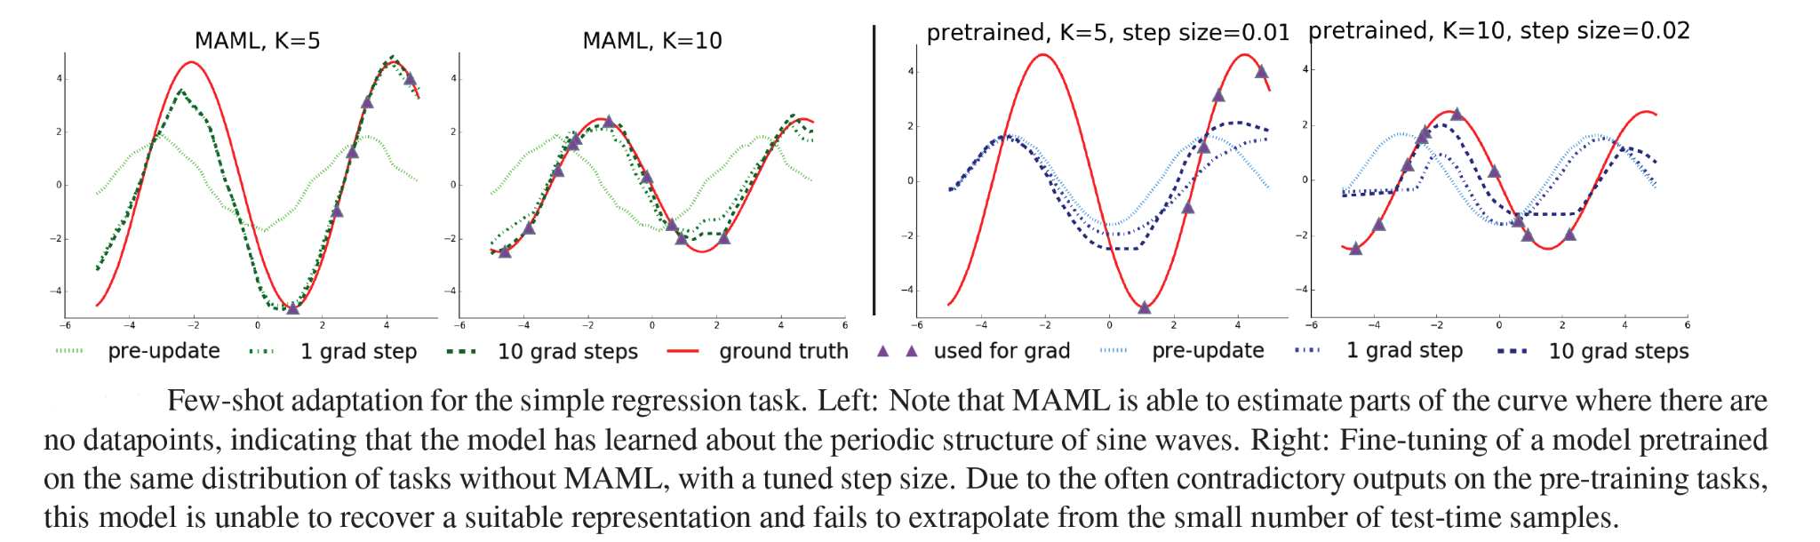

For regression and classification tasks, horizon  was set to 1, the model was a neural network, while the meta-training-set was composed of random sinusoidal functions with arbitrary parameters (within fixed ranges). Subsequent few-shot training considerably outperformed non meta trained models.

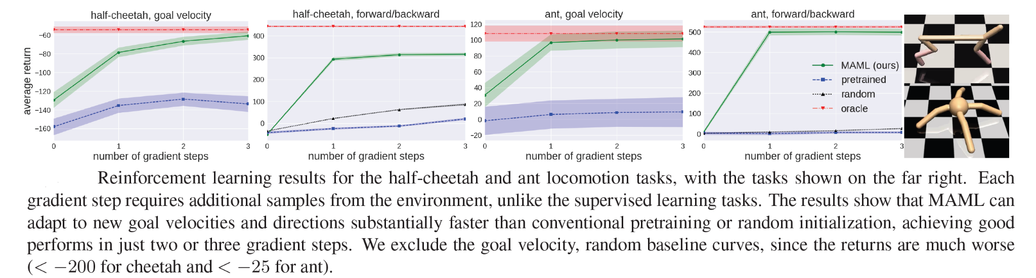

For RL experimentations with MAML, authors used a policy network, directly optimized by vanilla policy gradient, while TRPO was used as meta optimizer, proving the enhanced adaptability of the agent for 2D Navigation and robot locomotion (Deep RL), but obviously several other application frameworks can be designed and experimented.

1. SKILL BASED REINFORCEMENT LEARNING

A growing tendency in RL problem modeling is the usage of the concept of skills, intended as higher level actions, modeled implicitly or in some embedded or latent space. Such internal representation is exploited to solve several problems like computational intractability of distributions over actions (usually modeled in continuous space, especially in robotics), or improve long term sight when planning, considering skills as blocks of actions. Additionally, the whole setup allows them to learn in the skills space and potentially transfer them to other agents. Three approaches wil, be presented, providing a wide overview of the potential of such an approach.

3.1 DADS: Dynamics-aware (unsupervised) discovery of skills

Idea here is to learn a set of low level skills: sequences of actions, with an easily predictable outcome, using a model free approach, with the aim of making model-based control more easy. In fact, the new set of obtained skills will provide a better representation (behavior space), on top of which predictive models can be learned. We can look at such an approach as a specialization of the meta learning idea for RL, where actions are brought to a new level of abstraction in order to extract prior knowledge and enhance future specialization capabilities of the agent.

Objective function is based on the mutual information principle, demonstrated to be useful to encourage exploration in RL. . Maximizing  w.r.t. to  amounts to maximizing the entropy  of  while minimizing the conditional entropy 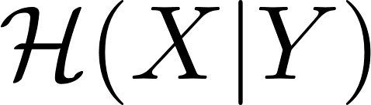.  is generally functions of the states, while  a function of actions. High entropy makes policy more explorative, learning diverse skills maximally covering the state space. MBRL estimates dynamics of environment, learning a model 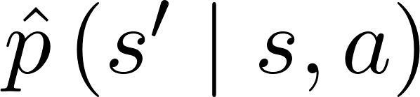, able to predict a certain trajectory  without needing any interaction with the environment (sample efficient).

At training time, given an MDP without rewards, with continuous action and stochastic transitions, a skill conditioned policy 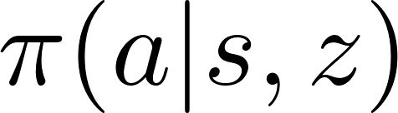 is learned, as well as a skill conditioned transition function 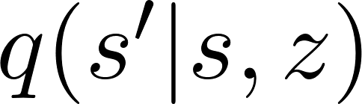, called *skill-dynamics*. Such a function can be viewed as a future state predictor given a current state and a skill from the distribution 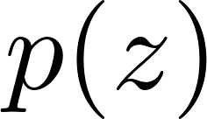 over the skill space .

Basic idea to learn skills is to measure how much a certain  has predictable (large) impact on the environment: minimize entropy of a new state given a certain state and a skill while maximizing the diversity of transition produced in the environment.



Using the definition of conditional mutual information loss is redefined as



Authors assume the generative process , where  is the arbitrary skill prior, 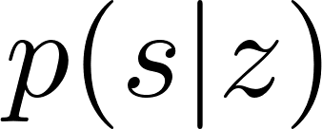 is the stationary state distribution induced by the policy 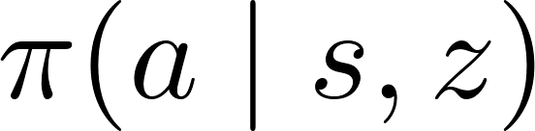 and 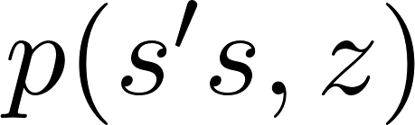 transition distribution under skill . Last term is intractable, but can be variationally approximated by 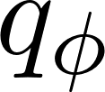, lower bounding the whole objective:

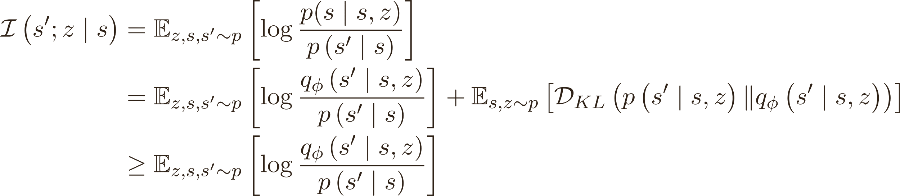

being  not negative. Variational approximation is then optimized alternatively along with 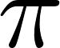: first step is minimizing the KL w.r.t. to the parameters  and hence tightening the lower bound (assume i.e. that a neural network is used as approximator ), second step is maximization of , considering the log difference as the approximation of the unknown reward function. However 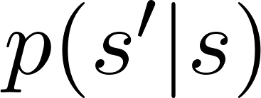 is intractable, so the function is approximated by sampling:



encouraging  being predictable under  and diverse from previous ones due to sampling.

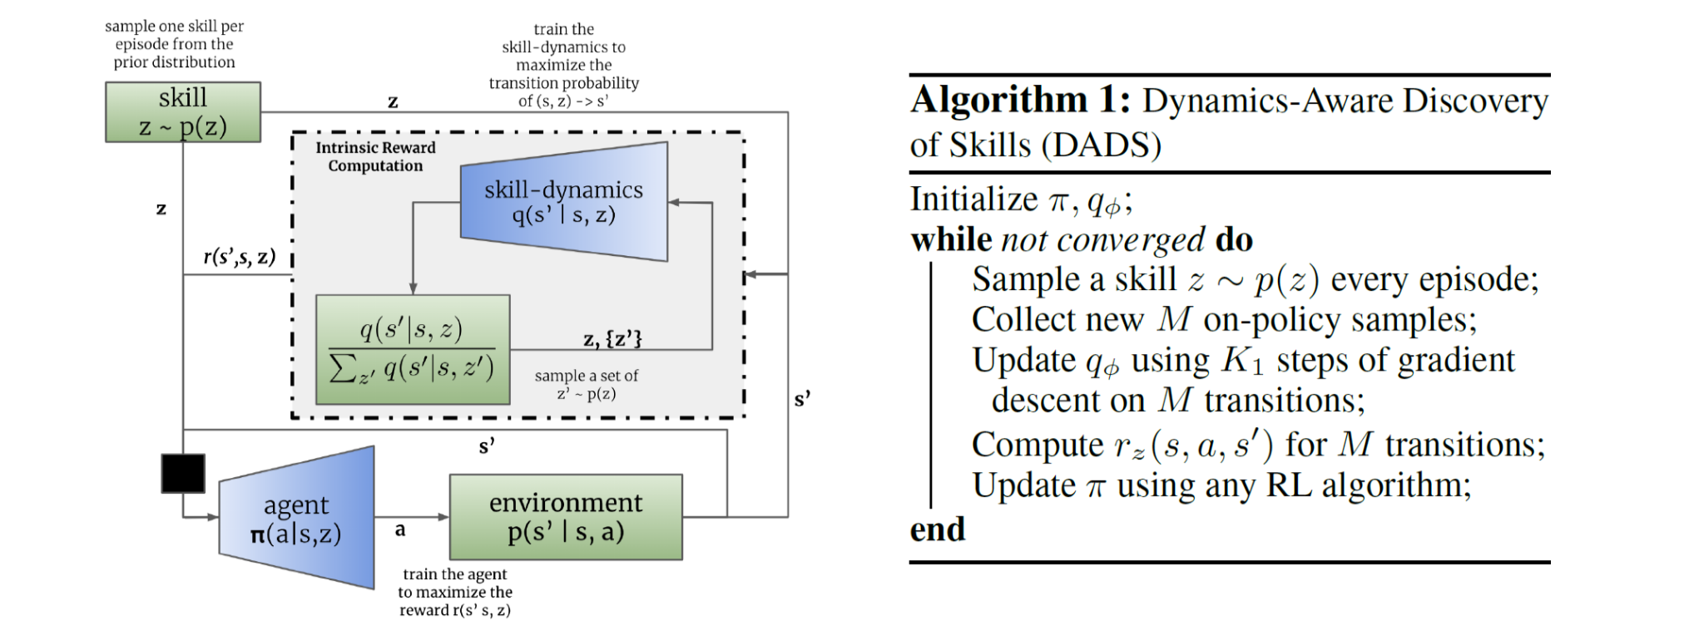

At test time, once reward function has become available, agent is able to plan in  using the model  of the learned skills  to maximize . Planning using skill dynamic is performed by model-predictive-control (MPC) generating a plan as an ordered set of skills 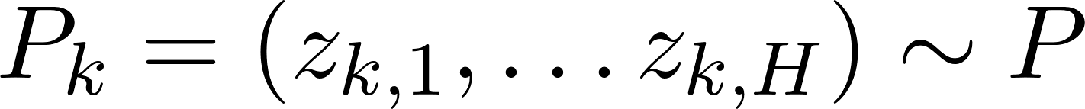 over horizon . Thanks to dynamic awareness acquired during training, planner has now access to the transition dynamics 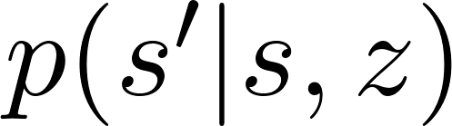, so a plan can be computed in the skills latent space . Elements of the sequence are then modeled with a Gaussian , and their parameters are updated via Model Predictive Path Integral (MPPI), so that action can be executed sampling a skill and executing 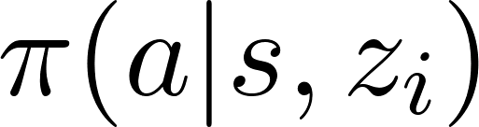 .

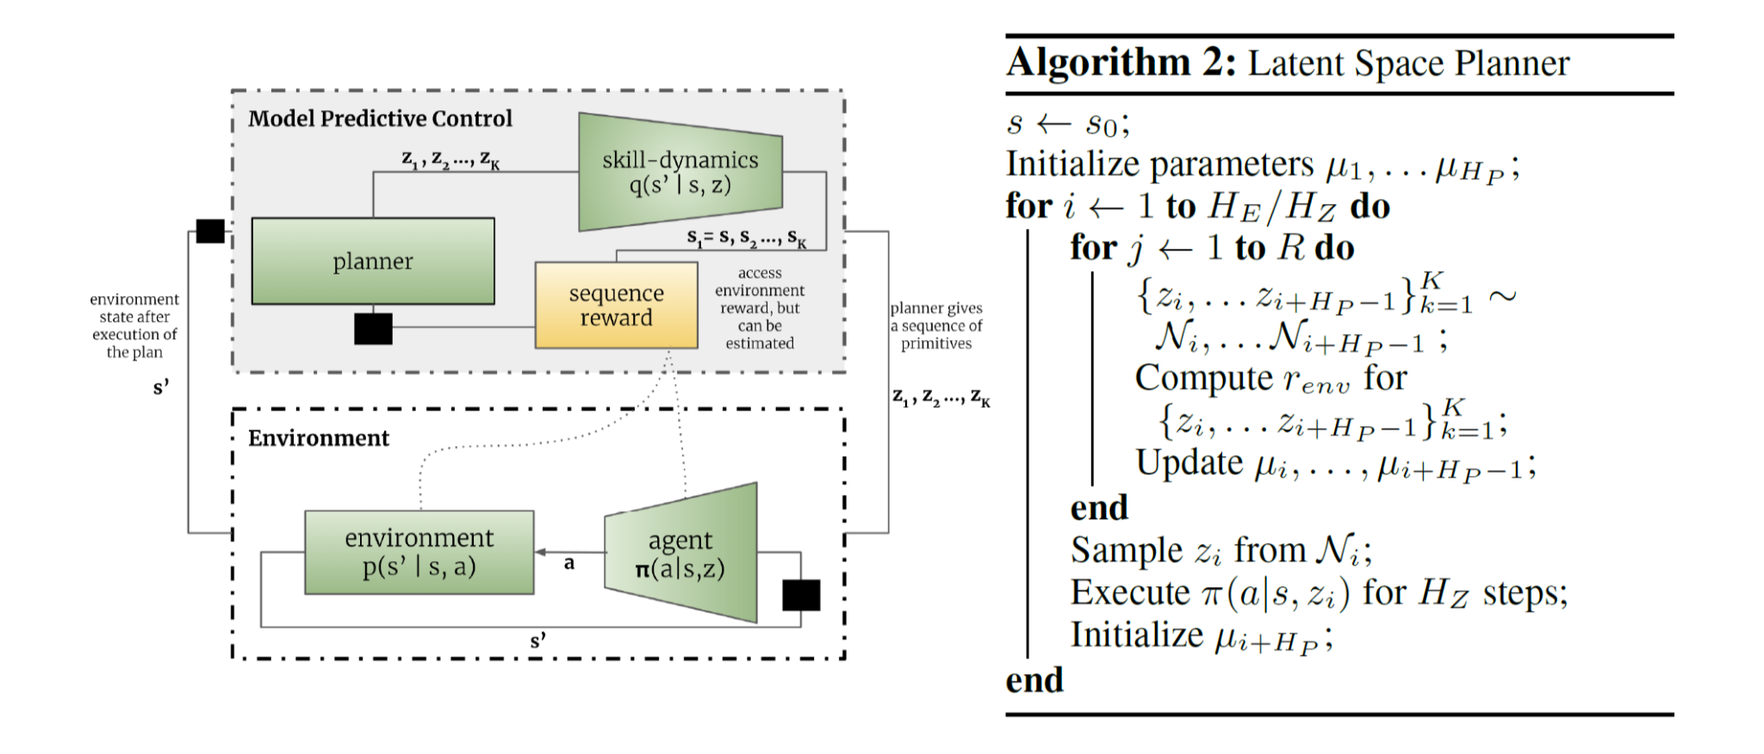

Qualitatively, experiments found the skills discovered by DADS to be predictable and stable, in line with implicit constraints of the proposed objective.

One of the significant advantages of the proposed objective is that it is compatible with continuous skill spaces. Hence large embedding can be used learning a large number of skills in a space proved to be smooth .

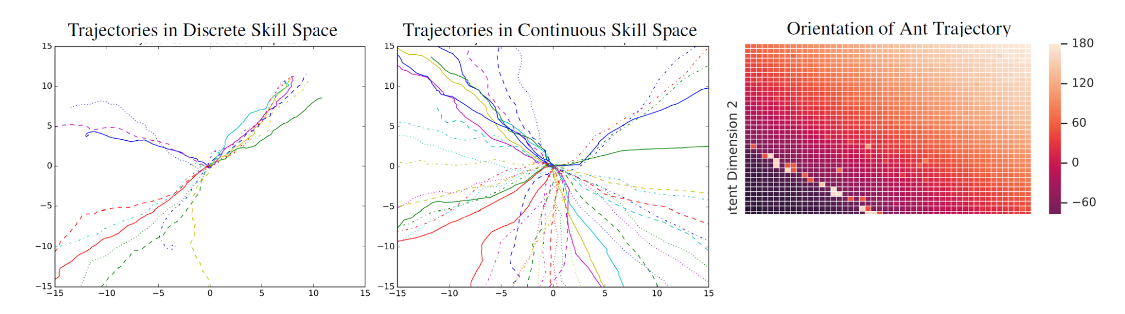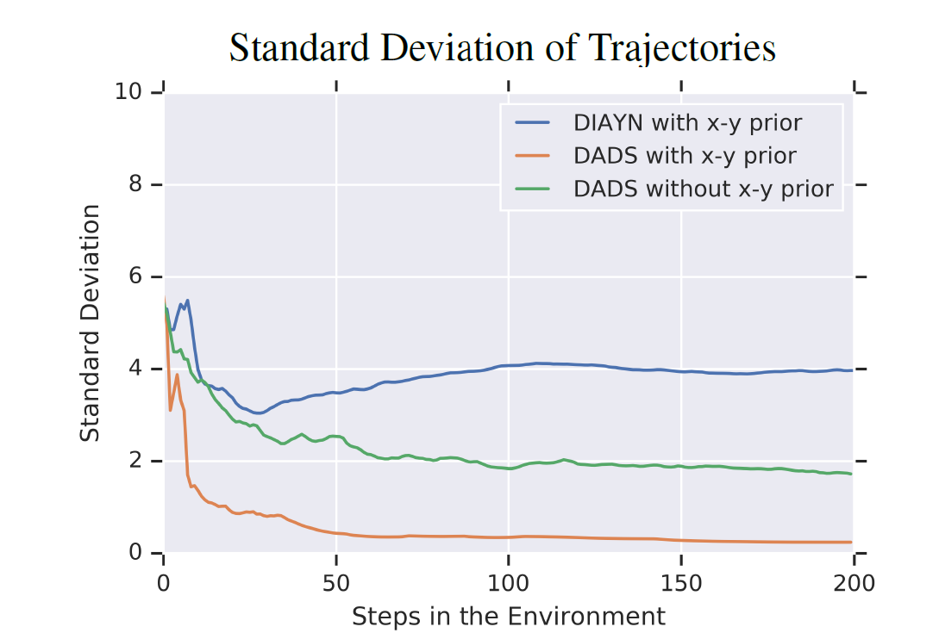

Primitives must exhibit low-variance behavior, which enables long-horizon composition of the learned skills in a hierarchical setup. Skills learned by DADS show significant control over the trajectories generated in the environment.

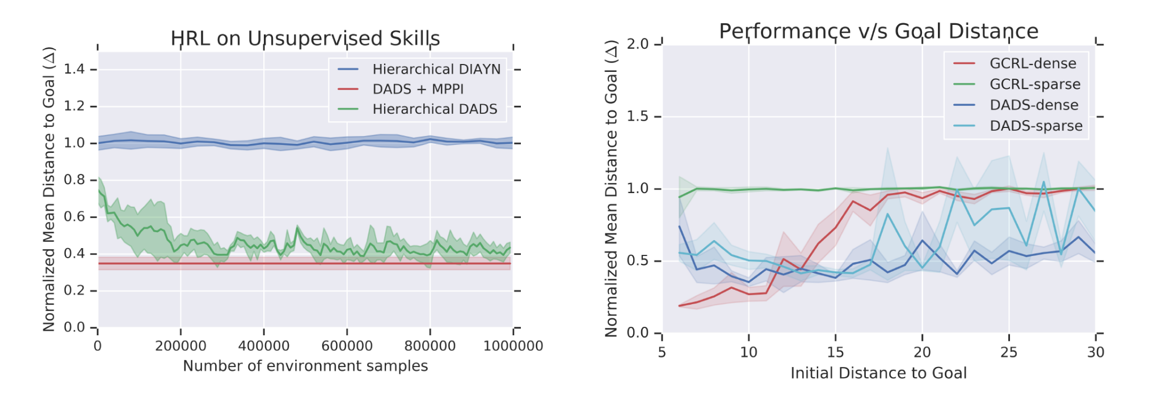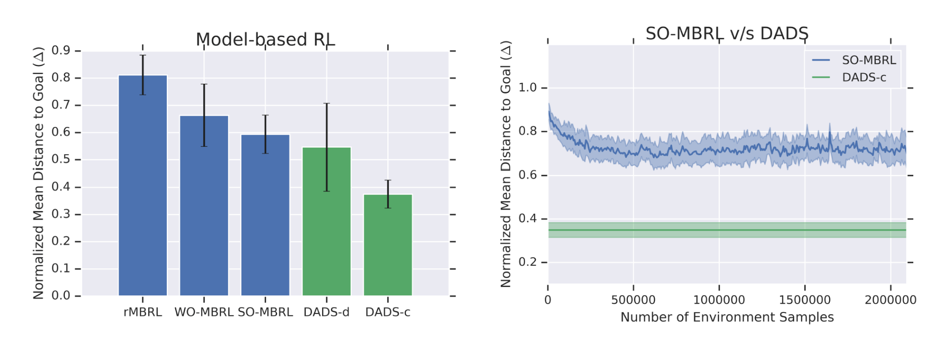

Comparisons involved other MBRL models and two DADS versions, respectively using discrete and continuous primitives, proving the former to outperform the latter in zero shot planning.

RL training was baselined with another skill discovering algorithm (DIAYN) and also with model free and goal conditioned algorithms, varying on reward density. Results highlight the utility of learning task-agnostic skills, showing that latent space planning can be leveraged for tasks requiring long-horizon planning.

3.2 SPiRL: Skill Prior Reinforcement Learning

Context is maximum entropy RL, authors propose an offline framework to learn a skill prior over past stored experiences, such that only the most useful and promising parts of the embedding space  are explored. Once skills are learned, they are exploited to accelerate the solution of any downstream task, this time with a hierarchical policy.

Learning happens through a dataset  of recorded experiences, in the form of state-action trajectories  on a diverse set of tasks. Such data are *unstructured*, not containing annotations of tasks, sub-skills, or guarantee to lead to the goal state.

Skills  are sequences of actions with a fixed horizon , modeled in the  latent space.

Skill latent variable 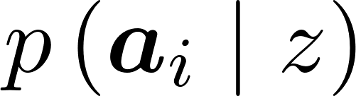 is learned sampling training instances to maximize the ELBO:

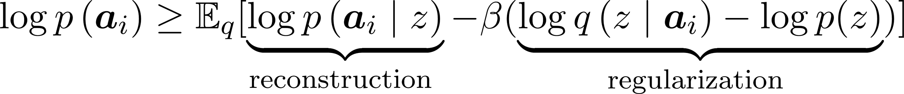

Skills are handled through amortized variational inference, via two deep neural networks: encoder 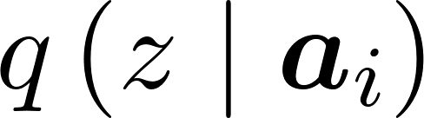 and decoder , which output the parameters of the posterior and output distributions. Although authors claim of having tried most complex distributions (mixtures and multimodal), prior  is Gaussian as well, so that the generative model of a skill is just sampling and decoding.

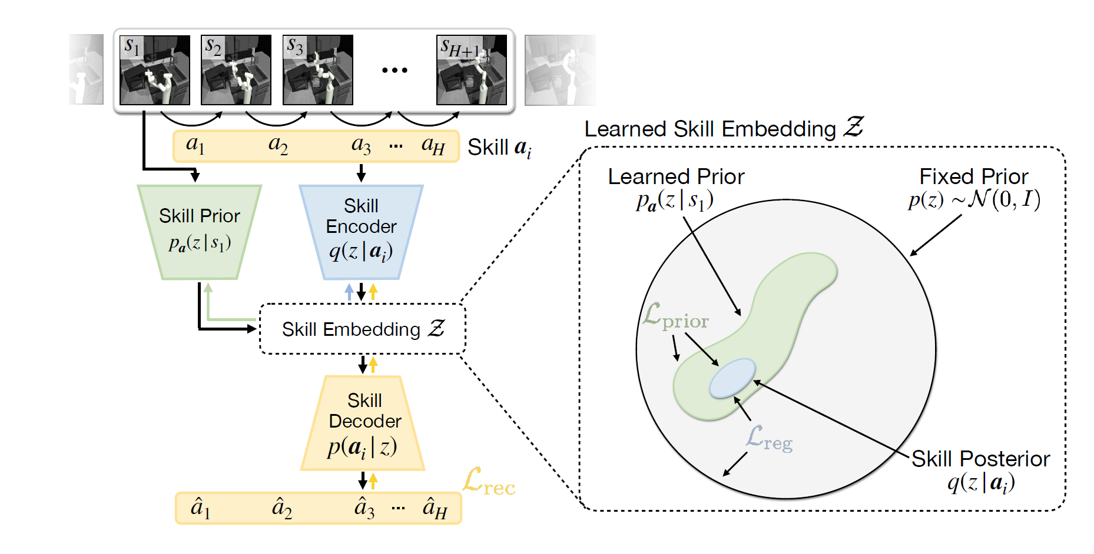

Intuitively, the current state should provide a strong prior over which skills are promising to be explored and, which ones not, so a state conditioned skill prior 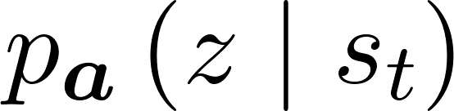 is modeled too. Such prior can be learned minimizing Kullback-Leibler divergence between the predicted prior and the inferred skill posterior .

Using the reverse KL divergence 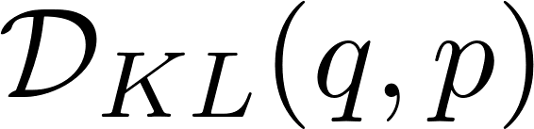 instead of 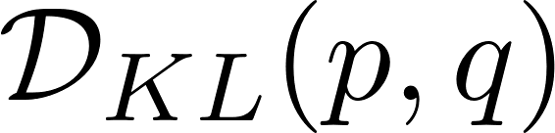 ensures that the learned prior is mode-covering: it represents all observed skills in the current situation. Skill embedding networks and priors are jointly optimized ensuring stable convergence.

Once priors have been learned, a high level policy 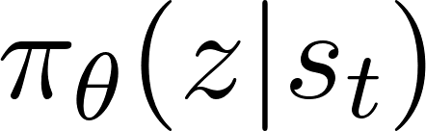 can be trained, performing the sampled skills as the decoded  step actions sequence. Such an approach has been demonstrated to also facilitate long-horizon task learning, allowing temporal abstraction.

To train such a policy, authors adapted the state of the art Model Free Entropy Maximization RL algorithm SAC (Soft Actor-Critic). Turning point is the re-definition of the entropy term in the loss:



The entropy is equal to the negated KL divergence between the policy and a uniform action prior 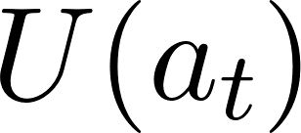: .

In the scenario previously defined, anyway, entropy should be redefined according to latent skills, and their prior is known to be not uniform, hence the resulting adapted loss would be:



leading to the following variant of SAC: SPiRL.

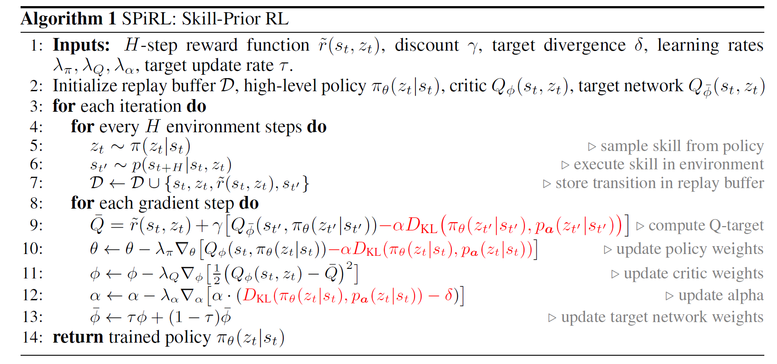

Evaluation was based on three tasks, one concerning navigation and two manipulation, using data gathered from each environment so that a large number of skills should be extracted. Flat and Hierarchical baselines were used to prove advantage of skill approach, evaluating the success rate per step.

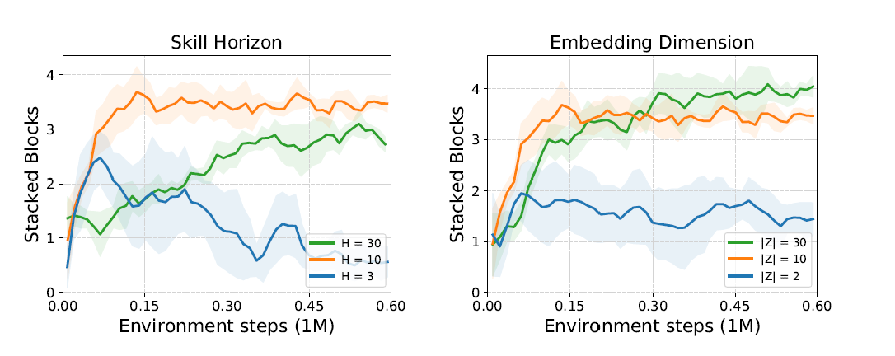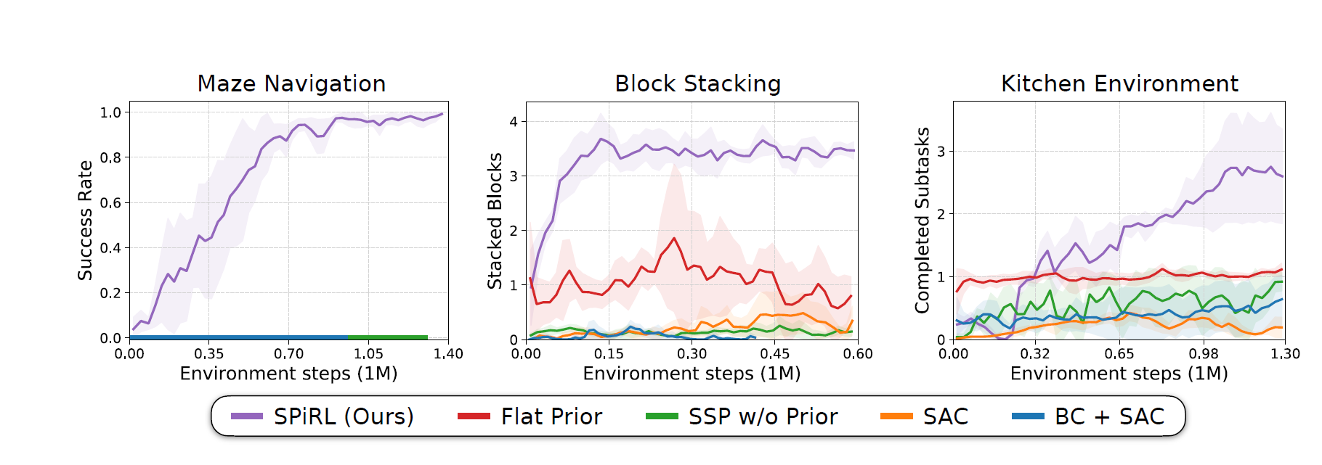

Author also evaluated the importance of the skill space dimensionality  and the impact of the horizon  (they only used it fixed in this work). Such a parameter turned out to be determinant for the planning capacity, regulating the tradeoff between too short sighted plan and too large space exploration (slowering convergence). Impact of  was mainly related to the problem complexity, looking like that once a certain dimensionality threshold was reached, its cardinality becomes not meaningful.

3.3 Actionable Models

Like SPiRL, this framework aims to reuse stored observations (knowing goal states), and in a Meta-Learning-like philosophy, to use such offline experience to make agents able to reach goals in unseen environments. RL here is based on conservative Q-Learning with hindsight relabeling, regularized for offline learning. Initial Q-Learning loss would look like:

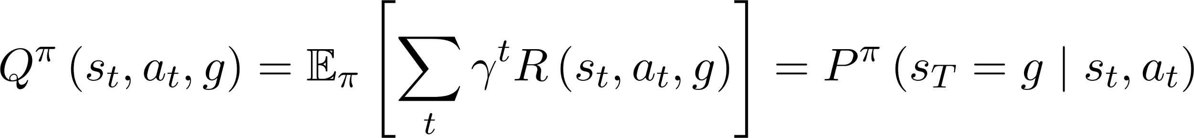 .

Assuming episodes to terminate when goal state is reached, using TD-learning to maximize the expected return, so inducing a greedy policy .

Authors’ desired behavior is to follow as much as possible positive trajectories present in the dataset (the ones which ended up reaching a goal state), penalizing Q-values for unseen actions 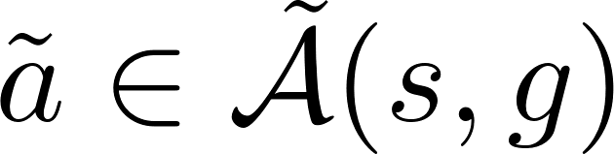. For this reason unseen negative actions are sampled according to a soft-max distribution over their Q-values: .

Idea now is to encourage agents to reach long horizon goals, chaining seen trajectories, without specifying any subgoal. To do so, every trajectory landing in current goal state  is labeled with 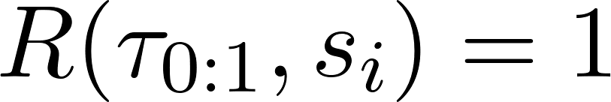, otherwise the current Q-value 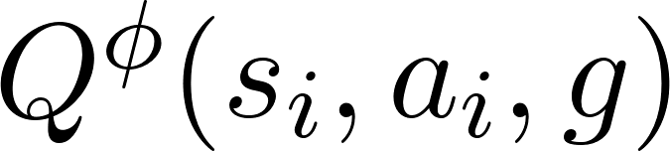 is taken, so that if there is an evidence 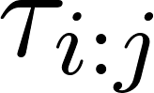, proving that  can be reached from , reward would propagate through the Q-values of previous stats 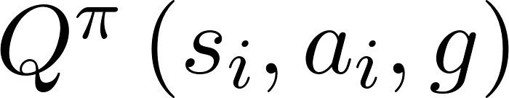 and eventually also to 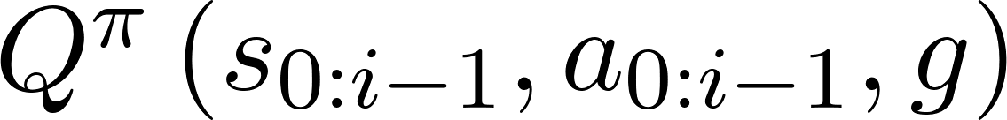 and so on, so that  would become a chaining point for the two trajectories.

To handle the situation when there is no pathway from  to [](https://www.codecogs.com/eqnedit.php?latex=g#0), authors applied a conservative regularization technique sampling unknown actions as described before, so that the Q-function is trained minimizing:



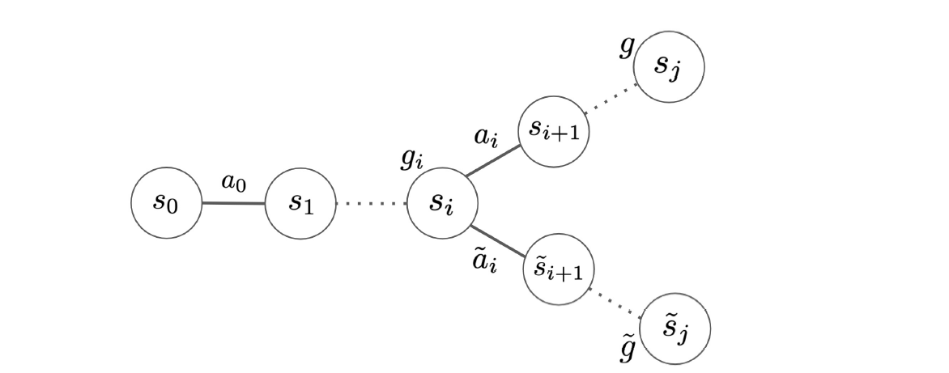

where  is the TD-target given by:

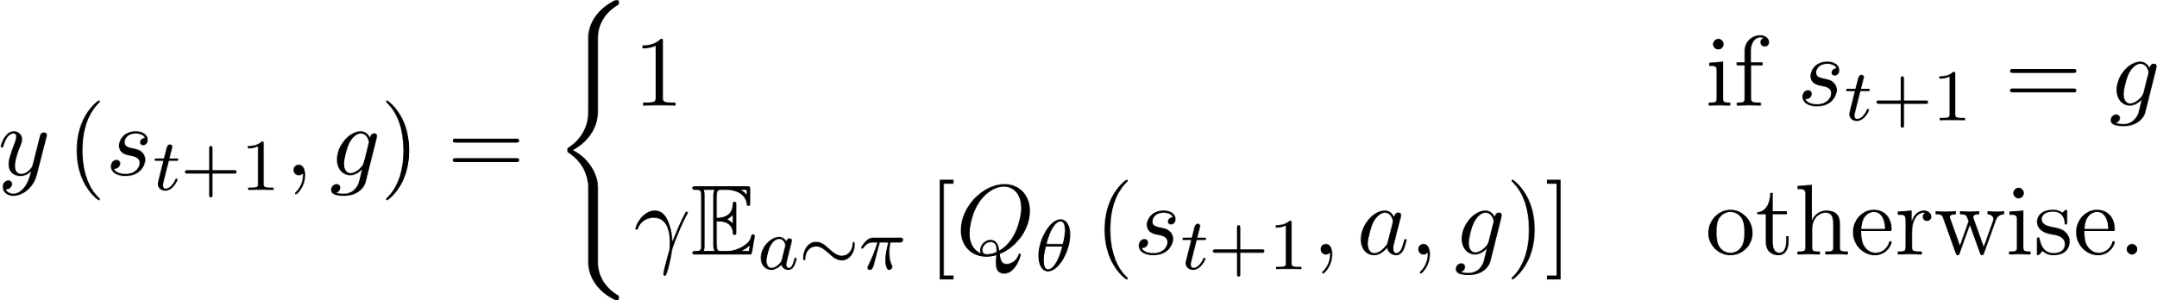

Being sampling not differentiable gradient does not propagate through the other regularization term 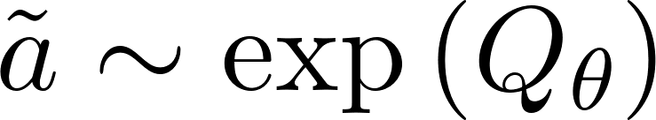.

Skill learning from an offline dataset can happen as follows (in this setup a skill is just a sequence of actions given an initial state that can reach a known goal state), adapting the Q function to the offline experience.

The trained Q-function can also be used as a general purpose prior (like done with meta learning) on which to fine tune the agent. Authors also suggest that their loss can be used during online task specific RL, weighted by a  mixing-in probability coefficient: .

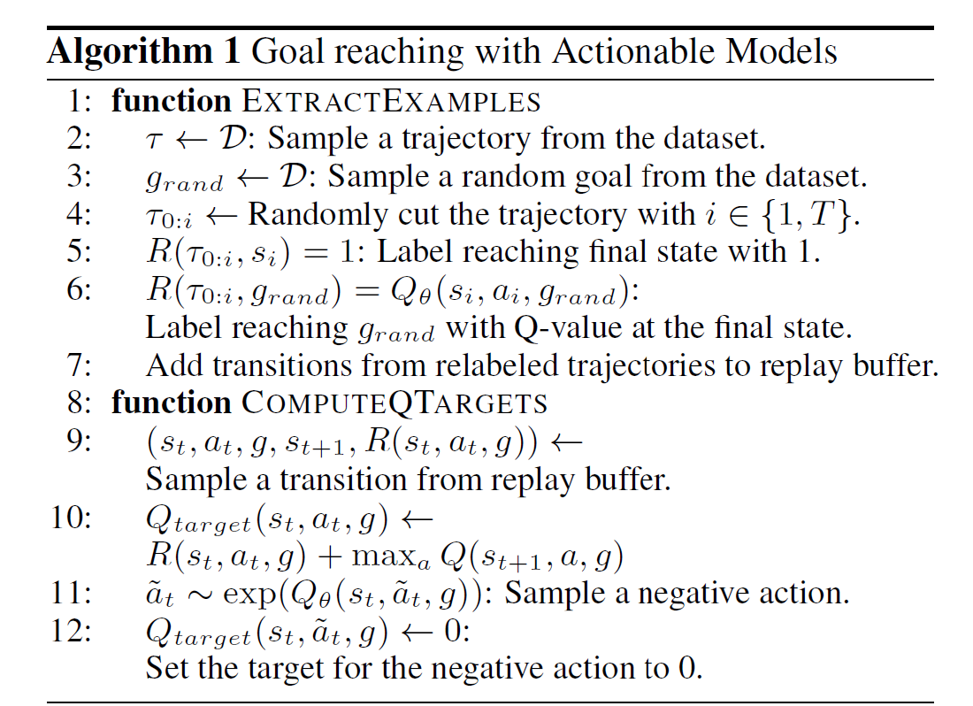

Experiments with Actionable Models were focused on real-world image based experience. The policy architecture follows the QT-Opt framework with an additional Q-function input for the 472x472x3 goal image, which is concatenated with the current robot camera image before being fed into a convolutional tower. The used dataset was private , containing RL training traces for 12 diverse tasks and environments in both simulation and the real world, coming from other past RL experiments. None of the traces were generated by goal-conditioned policies. The success rates ranged from 5% to 55%, with over 800,000 episodes, which altogether amounts to over 6 months of continuous robotic interaction on 7 KUKA robots.  
The framework outperformed other proposed models for training goal conditioned policies, Q-learning with hindsight relabeling (with both positive and negative goals).

Further details involving QT-Opt have been judged not interesting for this survey.

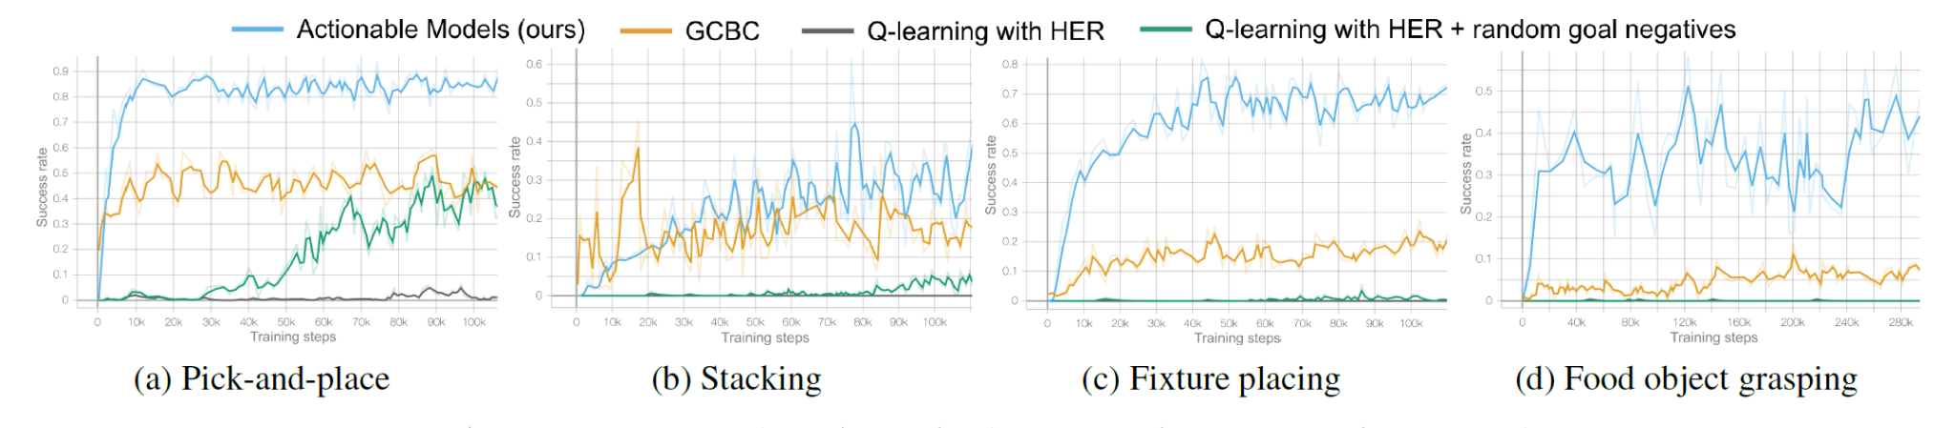

Real world visual tasks were experimented as well, providing an image of the goal state and then reset object position, proving learned policy to accomplish several tasks with good success rates. Claimed goal chaining capability was assessed as well, demonstrating long term goals being not reachable without the proposed conservative regularization machinery.

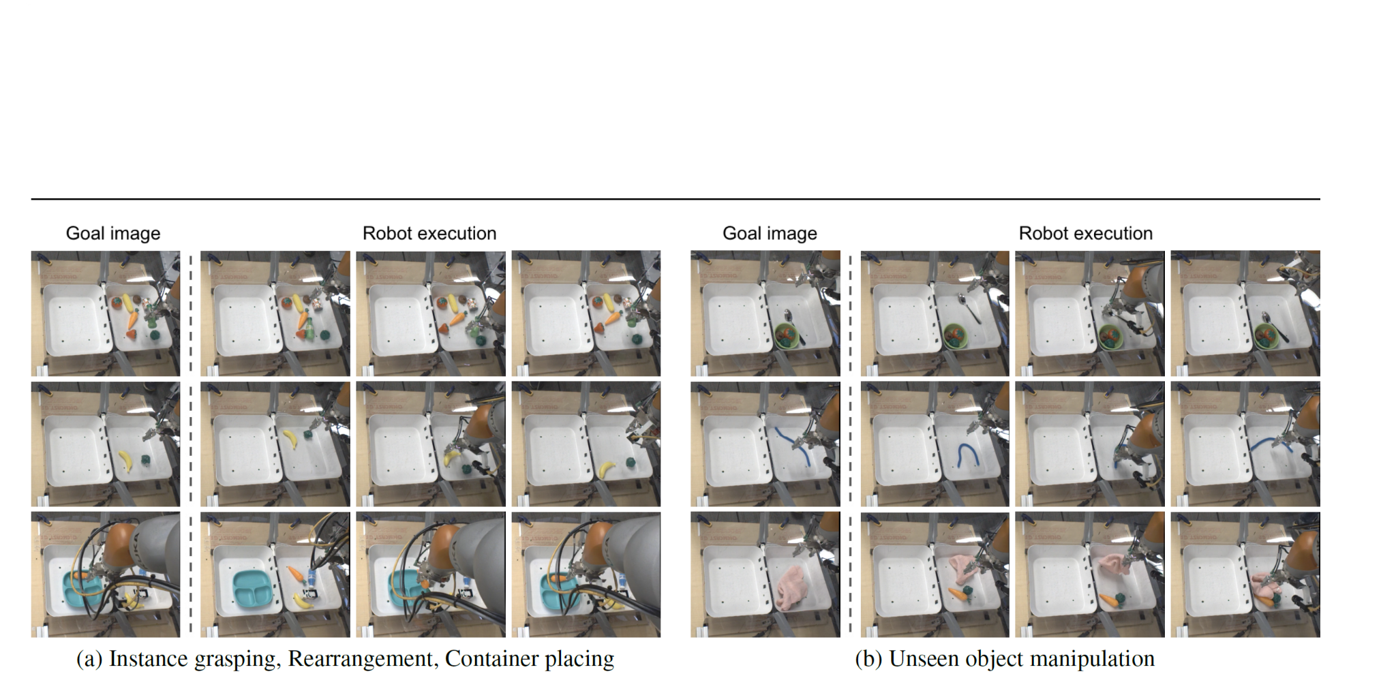

Experiments also proved implicit capabilities of representation learning, using the framework for offline pre training (QT-Opt), demonstrating a significant drop in success rate without Actionable Models for complex tasks, suggesting that acquired functional knowledge is beneficial for learning composed robotic skills (implicitly embedded in the target Q-function).

4. EXPERIMENTS SUMMARY

|  | Method | Task | Model | Dataset / Simulator | Metric | Compared baselines | Proved Concepts |
| --- | --- | --- | --- | --- | --- | --- | --- |
| MAML  (REG) | Meta train + Evaluate on K-shot learning tasks. | Regression on sinusoidal function | ReLU NN, 2 hidden layers of 40 units | Random generated sinusoidal functions | MSE | Random initialization , pre-training,  oracle | Meta Learning accelerates learning on downstream tasks on the three different tasks. |
| MAML (CLASS) | Image Classification | ReLu CNN  4 levels:  256, 128,64,64 | Omniglot,  MiniImagenet | Acc. | K-shot state of art models |
| MAML (RL) | 2D Navigation, Locomotion | Policy NN, 2x100 ReLU HL (TRPO + Vanilla grad) | rllab benchmark  suite | Avg. Return | Pre-training. random, oracle |
| DADS (MBRL) | Unsupervised skill discovery + downstream planning RL task | Ant navigation  (dense reward) | State of the art MBRL for zero shot planning (PETS) | Simulation from MuJoCo environments in the OpenAI gym | Mean Distance to goal | Random, Oracle trained on same task | - Discovering capacity for general purpose skills - Skills are composable, -High dim. scalability,  - Skills low variance  - Latent space planning  - Continuous primitives outperform discrete ones. |
| DADS (HRL) | Ant Navigation with different goals | DADS + MPPI based planner,  Hierarchical DADS | Hierarchical DAYIN |
| DADS (GCRL) | Ant navigation dense reward, sparse reward | Goal conditioned RL : Soft actor critic | Not specified GCRL model |
| SPiRL | Collect data simulating future task + Compute SPiRL priors +  evaluation | Labyrinth navigation, Block stacking, Kitchen environment | SAC- SPiRL | D4RL benchmark | Succ. Rate | SAC  Behavior cloning SAC  Flat Prior  H-SSP (train skills without priors) | - Leveraging unstructured datasets to accelerate downstream learning  -Skill priors improve downstream exploration  - Piors transferability |
| Ac. Mo.  (visual Goals) | Feed the dataset to the model and the evaluate goal reaching on downstream tasks. | 4D space manipulation with visual goal (both real and simulated) + complex manipulation tasks to test goal chaining capability | Policy architecture following the QT-Opt framework with an additional Q-function for images (Cross entropy loss) | Data from other RL simulation from KUKA robots | Succ. Rate | GBC: goal conditioned behavior cloning, Q-learning with hindsight relabeling | -Overperform w.r.t Q-Learning and behavior cloning goal conditioned algorithm.  - Learning capabilities with camera images  -Goal Chaining supported  - Learning accelerating effect for downstream tasks. |
| Ac. Mo.  (Goal Chaining) | Compare with unregularized model to prove goal  chaining |

5. APPROACHES COMPARISON

All the algorithms taken into account were designed sharing a similar goal: extract an initial configuration to improve the learning capacity or training speed of some model.

For sure MAML represent the highest-level realization of such idea, being in fact model-agnostic; at the same time it turned out that such approach may seldom necessitate additional machinery to work with non trivial models, avoiding for example high order differentiation issues which make it still hard to be scaled for recent year giant over-parametrized models. Authors partially solved the problem using Goodfellow’s assumption about local linearity of ReLu neural networks, and hence substituting Hessians with their first order approximation and achieving a considerable speedup in the meta training phase. We can also say that MAML can be viewed as a “compelxity-conservative” approach, in the sense that it trains the actual model parameters without adding any other (unlike for example what LSTM meta learning does).

Staying on the RL models, what the other three approaches did, was something slightly different, although still designed to enhance adaptation capabilities: they found some blocks of actions with predictable outcome and encouraged agents to use them in downstream applications, both to plan and further learn. Authors empirically proved the efficiency of the framework for robots within an almost fixed environment (like in an assembly line), computing states as convolved images.

In particular, the Actionable Models approach almost totally relies on replication of already executed actions, relegating exploratory behaviors only to cases where a path to solution is not known. We might also venture to say that their Q-function is quite similar to a page-rank, with the  parameter similar to a teleportation probability when used as an auxiliary loss. Main strength of this approach is its controlled aggregative power (goal chaining): agents may be provided with data gathered with any kind of policy and tasks and reuse best successful behaviors discovered in previous experience (exactly what linguistically is intended as “skill”) in its current environment.

The remaining two approaches, on the other hand, point to the modeling of skills through latent variables, using past experiences to better teach agents its own capabilities and better model the environment (DADS) or to compute a more convenient and high level starting point for further learning (SPiRL), in a meta learning like fashion.

The two approaches are far from being disjoint or complementary, overlapping more than once. DADs aims to learn simple and predictable sequences of actions, trying to focus on the generated transitions (dynamics) as well as SPiRL aims to learn the best high level policy with respect to skills embedding in the current state. SPiRL learns a skill prior, penalizing the Kullback-Liber divergence between predicted prior and inferred posterior of a latent variable model, enforcing skill predictability too. DADs does this explicitly, optimizing the expected environment outcome  conditioned on state and skill: the so-called dynamic transition, maximizing mutual information on subsequent space, with the advantage of having  further reusable for MBRL. Additionally in SPiRL, Gaussian skill latent variable made the exploration of large skill spaces a tough task; on the contrary, in DADs, the wiser usage of variational approximations manage to solve potential computational intractability making approach easily scalable and even possibly explorative thanks to the entropy regularization. Finally, DADs also empirically seemed not to suffer any horizon  related issues when planning, proving high level policy to be able to perform long term control. In the end, SPiRL appears a bit more closer to the Actionable Models idea, building a latent variable framework to better reuse past experience in new downstream tasks, while DADs exploit past experience to meta learn agent dynamics (environment response to skills), discovering and filtering potentially also unseen skills.

6. CONCLUSION AND FUTURE APPLICATIONS

Analyzed works proved the potentialities of skill based approach in a number of RL approaches, enhancing both learning speed and planning capabilities, confirming the effectiveness of the meta learning idea. Theoretical foundations were strong, combining classical ML, SLT, neuroscience, information theory, probabilistic models and variational calculus. Observed experimental results also proved the effectiveness of the algorithms and the extremely wide range of applications they can deserve.

All works started more or less from the same idea, demonstrating that a variety of possible ways of realizing it are possible (maybe they can also be combined one with each other) and that they can be integrated with existing learning methods without too many issues.

At the same time such a research branch also turned out quite challenging, because of the amount of theoretical and technical knowledge needed, contemporary deep and large sighted: especially when it comes to robotics related applications, multidisciplinarity of the research team becomes determining (a lot of research contributions comes from private companies instead that from academic institutions).

Anyway the strength of the two main ideas appeared still far from being totally understood and explored, though their enormous impact on model performance has already been demonstrated, for example thinking about the reuse of data and past experiences, which is becoming a crucial feature in AI and algorithm design; the path that these methods are drawing seems to address such a research direction. Integration with other growing fields of AI like Continual Learning and Reservoir Computing also appear a natural subsequent step for building agents with strong general purpose capabilities and contemporary high and “cheap” specialization potential.

7. BIBLIOGRAPHY

Finn, C., Abbeel, P., & Levine, S. (2017). **Model-agnostic meta-learning for fast adaptation of deep networks.** *34th International Conference on Machine Learning, ICML 2017*, *3*, 1856–1868. Retrieved from http://arxiv.org/abs/1703.03400

Pertsch, K., Lee, Y., & Lim, J. J. (2020). ***Accelerating Reinforcement Learning with Learned Skill Priors*. (CoRL).** Retrieved from http://arxiv.org/abs/2010.11944

Sharma, A., Gu, S., Levine, S., Kumar, V., & Hausman, K. (2019). ***Dynamics-Aware Unsupervised Discovery of Skills*.** 1–21. Retrieved from http://arxiv.org/abs/1907.01657

Chebotar, Y., Hausman, K., Lu, Y., Xiao, T., Kalashnikov, D., Varley, J., … Levine, S. (2021). ***Actionable Models****:* ***Unsupervised Offline Reinforcement Learning of Robotic Skills***. Retrieved from http://arxiv.org/abs/2104.07749

Hausman, Karol & Springenberg, Jost Tobias & Wang, Ziyu & Heess, Nicolas, & Riedmiller, Martin. (2018). **Learning an embedding space for transferable robot skills,** *International Conference on Learning Representations*. *Retrieved from https://openreview.net/forum?id=rk07ZXZRb***.**

Andrychowicz, M., Wolski, F., Ray, A., Schneider, J., Fong, R., Welinder, P., … Zaremba, W. (2017). **Hindsight experience replay**. *Advances in Neural Information Processing Systems*, *2017-December*(Nips), 5049–5059. Retrieved from http://arxiv.org/abs/1707.01495

Kalashnikov, D., Irpan, A., Pastor, P., Ibarz, J., Herzog, A., Jang, E., … Levine, S. (2018). ***QT-Opt: Scalable Deep Reinforcement Learning for Vision-Based Robotic Manipulation***. (CoRL), 1–23. Retrieved from http://arxiv.org/abs/1806.10293

Gupta, A., Kumar, V., Lynch, C., Levine, S., & Hausman, K. (2019). ***Relay Policy Learning: Solving Long-Horizon Tasks via Imitation and Reinforcement Learning***. (CoRL), 1–13. Retrieved from http://arxiv.org/abs/1910.11956

Eysenbach, B., Ibarz, J., Gupta, A., & Levine, S. (2019). **Diversity is all you need: Learning skills without a reward function**. *7th International Conference on Learning Representations, ICLR 2019*, 1–22. Retrieved from http://arxiv.org/abs/1802.06070